Dignity Is a Baseline: Welfare Institutions and the Asymmetric Politics of Economic Disruption
Ben Smart
University of Copenhagen — Department of Economics
Welfare State Seminar — April 2026
Abstract
Workers exposed to routine-task automation are more anti-immigration than their material interests would predict, and the gap is systematically larger in some countries than others. The conventional answer is that welfare generosity buffers the political backlash: spend more, get less populism. This paper argues that the buffering framework misreads the mechanism. The mechanism, on a careful reading of the evidence, is asymmetric. Welfare institutions can fail politically in a specific, cumulative, and observable way; they damage the self-concepts of economically vulnerable workers and trigger a cascade of identity switching, misattribution, and defensive othering. They cannot, by symmetric operation, succeed. Dignity is a baseline good. Its absence damages. Its presence clears the ground for solidarity without producing it.
Using the European Social Survey (rounds 6–9, 34 countries), I show that welfare decommodification accounts for 72 per cent of the cross-national variation in the RTI→anti-immigration slope (r=−0.848, p<0.001, N=15), while welfare spending effort on the same sample is uncorrelated with the pattern (r=0.01). The damage side of the mechanism is visible across all specifications. The mirror-image protective effect on redistribution support is not. RTI predicts slightly higher redistribution support across all regimes, but welfare context does not detectably moderate the vulnerability→solidarity pathway, and a supplementary ISSP test on a different sample returns the same null. I treat this asymmetry as the theory's central prediction rather than as its limitation, and I ground it in three structural sources: loss aversion, the positional character of status (Gidron and Hall 2017; Kurer and Palier 2019), and the irreversibility of defensive identity investments. The contribution is the claim that compensation does not fail because compensation is insufficient. It fails because what welfare is has more political consequence than what welfare spends, and because what welfare does at the dignity margin runs in only one direction.
I. Introduction
A robust finding has emerged across comparative political economy since the foundational work of Autor, Levy, and Murnane (2003) on the task-based framework: workers in routine-task-intensive occupations disproportionately support populist radical right parties (Gingrich 2019; Kurer 2020; Im et al. 2019; Autor et al. 2020; Gallego and Kurer 2022). The pattern holds across countries, time periods, and measurement strategies. The cross-national variation in its strength is itself well-documented; the same automation exposure converts into anti-immigration sentiment more readily in some welfare states than in others (Vlandas and Halikiopoulou 2022; Caselli et al. 2021).
The conventional explanation for the variation treats the welfare state as a buffer against political extremism. Building on Ruggie's (1982) framework of embedded liberalism, this literature conceptualises welfare spending as compensation. Generous provision reduces the insecurity that fuels populist support; insufficient compensation leaves insecurity unaddressed. The operative variable is quantity. Spend more, get less populism. The framework is intuitive and theoretically tractable, yet on a cumulative reading of the evidence it is missing the mechanism it claims to describe.
This paper argues that the buffering account gets the mechanism wrong in two distinguishable ways, and that the errors compound. The negative case is that the framework cannot accommodate the evidence that has accumulated against it. Compensation that does not work, compensation that backfires, compensation that is resisted; three streams of evidence are documented in §II, and each pulls in a direction the buffering model does not theorise. The cross-national pattern in this paper's own data fits the same indictment. Welfare spending effort, on a matched 15-country sample, is uncorrelated with how strongly automation exposure converts into exclusionary sentiment (r=0.01). Welfare decommodification, by contrast, accounts for 72 per cent of the same variation (r=−0.85). What the data tells is not a story about quantity. It is a story about what welfare institutions do to the people inside them, and what they say in the doing.
The positive case is harder to state without committing to a stronger claim than the symmetric framing the buffering literature has worked with. The political effects of welfare design, I argue, are asymmetric. Welfare institutions can fail politically in a specific, cumulative, observable way; they damage the self-concept of economically vulnerable workers and trigger a cascade of identity switching, misattribution, and defensive othering that produces exclusionary politics (Bonomi, Gennaioli, and Tabellini 2021; Gallego and Kurer 2022; Wagner 2022; Patrick 2016). They cannot, by symmetric operation, succeed. Variation in how routine-task-intensive workers convert disruption into exclusion is robust across every specification this paper presents. Variation in how the same workers convert the same disruption into redistributive solidarity is small, non-significant, and not detectably moderated by welfare institutional context. Dignity-preserving welfare clears the ground for solidarity; it doesn't produce it. The asymmetry is what the buffering framework's symmetric assumption hides, and recovering it makes sense of a pattern the buffering literature has been struggling to explain in symmetric terms (Gingrich 2019; Stutzmann 2025; Bergman 2023; Fetzer 2019; Pelc 2025; Guriev 2024).
The mechanism, on my account, is the self-concept of vulnerable workers; their understanding of their own worth, their citizenship status, and their position relative to other groups. Welfare is the single state domain where economic vulnerability and institutional treatment meet. When a worker encounters the welfare state, the institution allocates resources and renders a judgement about that worker's claim to them. That joint operation is what makes welfare uniquely load-bearing as a communicator of citizen worth, and it is what a body of work in the recognition literature (Gidron and Hall 2017; Kurer and Palier 2019; Häusermann 2024; Wagner 2022) has been articulating in adjacent vocabulary. What welfare communicates determines whether disruption is processed through class identity, where it can support solidarity, or routed through cultural identity and the cascade developed in §III, where it produces exclusion. The data does not support the claim that welfare design routes disruption into solidarity. It supports a narrower claim: welfare design determines whether disruption is prevented from being routed into exclusion. That narrower claim, as it turns out, is what the asymmetric mechanism actually predicts.
The contribution is threefold. First, the paper connects previously isolated micro-mechanisms (identity switching, misattribution, defensive othering) into a single damage cascade with welfare institutional design as the upstream condition under which the cascade fires. Second, it explains why the symmetric mirror image of that cascade does not exist, grounding the asymmetry in loss aversion, the positional character of status, and the irreversibility of defensive identity investments. Third, it provides cross-national evidence that the political consequences of welfare design are visible only when welfare is measured by decommodification rather than by spending; a finding that challenges the buffering model's reliance on generosity levels as the operative variable, and that points the empirical agenda toward dimensions of welfare design that have been treated as descriptive detail rather than the place where the political action is.
II. The Limits of the Buffering Model
The dominant framework treats the welfare state as a buffer against political extremism. Its theoretical foundation is Ruggie's (1982) embedded liberalism bargain: democratic governments, recognising that economic openness creates losers, provide social protection as compensation, on the expectation that compensation dampens extremism. Contemporary applications test whether welfare generosity reduces radical right support (Vlandas and Halikiopoulou 2022; Halikiopoulou and Vlandas 2016; Ennser-Jedenastik et al. 2019). The operative variable is quantity. Spend more, get less populism.
But the evidence is harder on the framework than this account allows.
Compensation that does not work. Gallego and Kurer (2022) flag what they call a "concerning finding" from Gingrich's (2019) comparative study, the only careful cross-national analysis testing whether public policies aimed at alleviating labour market risks for automation-exposed workers prevent the political turn to protest voting. Gingrich finds that workers highly exposed to automation are not less likely to vote for populist parties in countries with more generous early retirement policies, more in-kind spending, or more protective labour market regulation. If the buffering model were correct, more generous welfare states should show weaker automation-to-populism effects. They do not.
Compensation that backfires. Stutzmann (2025) examines Germany's coal phase-out, a case where affected communities received substantial compensatory investment and where both compensation and interest group representation were fulfilled. Material conditions held; affected municipalities nonetheless showed higher abstention rates and lower support for the issue-owning party. Bergman (2023) theorises "self-undermining" policy feedback effects, whereby welfare interventions visibly benefiting groups that potential radical right voters view unfavourably can catalyse greater support for the radical right. Fetzer's (2019) analysis of Brexit makes the channel explicit: welfare cuts predicted Leave support through the erosion of political trust and efficacy, rather than through material deprivation. The institutional channel is doing the political work.
Compensation that is resisted. Pelc (2025) shows that a sizeable portion of workers resist being compensated out of work even when the compensation fully replaces their income, preferring reduced hours over unemployment at the same pay, and compensation from employers over identical compensation from government. The form, source, and meaning of compensation carry political weight independently of its material content. As Guriev (2024) observes, compensating the losers of economic transformation has proven much harder than economists assumed, not because of insufficient resources, but because of political and institutional constraints the buffering framework does not theorise. Kuziemko (2023) makes the complementary point on the demand side. Less-educated voters in the United States prefer predistribution (wage protection, work supports) over redistribution as such, suggesting the resistance Pelc documents is characteristic rather than anomalous.
Burgoon and Schakel (2022) provide the most careful recent empirical case for the buffering account, and the apparent contradiction with this paper's null on welfare spending is worth resolving directly. They find welfare generosity associated with reduced anti-globalization nationalism in European party platforms. Their result is real and their measurement careful. The contradiction dissolves once the units of analysis are kept distinct: Burgoon and Schakel measure platform language at the party level, while the analysis here measures attitudinal slopes at the individual level conditional on automation exposure. The mechanisms that translate aggregate welfare effort into party platforms (elite incentives, coalition arithmetic, electoral targeting) differ from the mechanisms that translate institutional encounter into individual self-concept and exclusionary attitudes. Both findings can be true. Welfare generosity at scale may dampen the supply of anti-globalization rhetoric in party systems while the demand for exclusionary attitudes among vulnerable workers responds to a different welfare dimension entirely. The contribution of this paper is to identify that dimension as decommodification rather than spending effort, and to locate it at the individual rather than party level.
The buffering model is not entirely wrong. Albanese et al. (2021) find that EU structural fund disbursements reduce populist voting in recipient regions, suggesting visible, tangible local investment can work where individualised transfers cannot. The finding cuts the same way as the asymmetric argument developed below. What the spending says about recipients, and about their relationship to the political community, is what does the work. Spending effort alone is too coarse.
III. The Asymmetric Mechanism
A. What the Evidence Demands
The central empirical pattern of §V is asymmetric. Welfare institutional context moderates the conversion of automation exposure into anti-immigration sentiment: the slope is significantly steeper in Liberal regimes than in Nordic ones, and the moderation tracks decommodification rather than spending effort. It does not detectably moderate the conversion of the same exposure into redistributive solidarity. RTI predicts slightly higher redistribution support across all regimes, but the cross-regime interaction is small and non-significant, and a supplementary ISSP analysis (Appendix C) returns the same null on a different sample and a different outcome variable. The damage mechanism is legible. The protective one is not.
The natural response is to treat the solidarity null as a measurement problem; a single-item redistribution scale, an insufficiently sensitive panel, missing mediators. The supplementary analysis suggests the null is robust to a few obvious alternatives, and on my reading it is also robust to the more defensible interpretation, which is that the mechanism itself is asymmetric. The picture I want to defend is not a symmetric sorting machine that routes vulnerability into solidarity or exclusion depending on the quality of the institutions filtering it. It is a one-way filter. Welfare institutions can fail politically, in a specific and cumulative way. By symmetric operation, they cannot succeed.
This is a stronger claim than the symmetric sorting account, and one a careful reading of the recognition literature has been working toward for some time. Gidron and Hall (2017, p. 26) find that right-populist voters "care as much, or even more, about recognition as about redistribution," and that compensation "is not what these people are looking for." Kurer and Palier (2019) make the complementary observation in the routine-worker context; what routine workers demand is "economic and cultural protection," and the second of those cannot be supplied through transfer payments. The buffering framework treats redistribution and recognition as fungible. They are not. The asymmetric mechanism developed below takes the non-fungibility as its starting point.
B. Why Welfare, and Not Something Else
The obvious objection at this point is that many institutions shape identity. Media environments construct group boundaries. Religious traditions supply moral narratives. Class structures generate interest coalitions. Why isolate welfare, and not any of these other plausible candidates?
The answer is that welfare is the single state domain where economic vulnerability and institutional treatment meet. Other institutions shape identity, certainly, but welfare is the one whose verdict has material and symbolic force at the same time. When a worker encounters the welfare state, the institution allocates resources and renders a judgement about that worker's claim to those resources, in the same act and at the same moment. This joint operation is what other identity-shaping institutions cannot match. Courts render judgement but rarely allocate resources to the individual judged. Markets allocate without judgement, or pretend to. Religious institutions render judgement but cannot compel. Only welfare does both, and it does them at the point of a person's maximum material dependence; which is also, not coincidentally, the point at which a person is least equipped to resist what the institution communicates about them.
This joint operation produces the conditions under which welfare becomes load-bearing as a communicator of citizen worth. Wagner's (2022) finding that recipients learn and mirror the recognition norms the state enacts on them is intelligible only under these conditions: because the encounter is materially consequential and judgement-laden, recipients cannot dismiss the signal as one view among many. They have to metabolise it. Soss (1999) documents the specific learning that follows. Programmes with respectful implementation foster civic engagement; programmes characterised by surveillance and conditionality generate alienation, and the alienation persists. De Blok and Kumlin (2022) extend the point with a finding worth dwelling on. Procedural fairness preserves institutional trust most strongly for those whose outcomes are unfavourable, which means implementation quality matters most precisely for those who are most economically vulnerable. The implication is one Banerjee and Duflo (2019) pose as a normative goal but which, in this paper's framing, is also a positive-empirical claim: what the welfare state says about you, when you encounter it, is part of what you know about yourself.
If welfare institutions shape the self-concept of vulnerable workers, the influence should be strongest where vulnerability is highest and institutional contact most concrete. Routine-task-intensive workers satisfy both conditions at once. Their material position is eroding, and they are disproportionately represented in the caseloads of visible welfare systems. This is why the cross-national pattern is detectable in ESS data; the sample contains the population on which the mechanism should have the most purchase.
Three further pathways extend the mechanism beyond direct recipients. The first is anticipation. Workers aware of their exposure to economic disruption factor anticipated future dependency into present self-understanding, and welfare institutions are the most legible signal of what that future dependency will look like. The second is narrative. How the welfare state treats its recipients shapes how welfare is talked about in political speech, in journalism, and at the dinner table, mirroring at the population level the recognition norms Wagner (2022) documents at the recipient level. The third is concentration. The population most exposed to automation is also the population most likely to have encountered, or to anticipate encountering, visible welfare systems. None of these aggregation pathways is instantaneous or lossless, but they are what Wagner and Soss mean when they describe welfare as a site of political socialisation that reaches beyond the encounter itself. A structurally distinct fourth channel runs through what Mettler (2011) calls the "submerged state"; tax expenditures and indirect benefits serving middle and upper-income groups that remain invisible as government assistance. Recipients of submerged welfare attribute their security to personal merit. Recipients of visible welfare are marked as dependents. The two groups look at the same welfare state but see different institutions, and the gap between what they see produces a political identity fracture: a large share of the population benefits from the welfare state without recognising it, developing meritocratic beliefs structurally at odds with the solidarity the welfare state would, in a more legible form, plausibly produce.
C. The Damage Cascade
When welfare institutions damage the self-concept, three responses follow. Each builds on, and is harder to reverse than, the one before.
The first is identity. Bonomi, Gennaioli, and Tabellini (2021) model how individuals move from class to cultural identity when class identity is degraded by economic disruption, and under cultural identity, redistribution demand decreases while cultural conservatism intensifies. The welfare state enters this model at a specific point. Stigmatising implementation degrades class identity directly, accelerating the switch. A worker entering a system that treats retraining as a citizenship right retains class identity; a worker entering a system of means-testing and surveillance has that identity doubly damaged, both by the disruption that brought him into contact with the system, and by the system's response to him once he is inside it. Ballard-Rosa, Jensen, and Scheve (2022) provide the downstream evidence; economic decline activates social identity processes producing authoritarian values through group status threat, and welfare institutional mediation, I argue, is the missing upstream variable. It determines whether the pathway they document actually fires. Im (2023) supplies further confirmation in panel data from Finland; it is expected status decline, not material hardship as such, that drives the radical right shift among routine workers. The expectations workers form about their future status are themselves shaped by what they observe of how the state treats people in their position.
Once cultural identity is in charge, grievances misattribute. Economic frustration gets pointed at cognitively available scapegoats. Gallego and Kurer (2022) identify three factors compounding to produce this: psychological gratification from blaming outgroups, political supply of anti-immigrant narratives, and automation's gradual invisibility as a target of blame. Wu (2022) confirms the misdirection empirically; workers at higher automation risk oppose immigration but show no different technology preferences. A worker pointed at the actual cause of his vulnerability does not respond politically; a worker pointed at a substitute for the actual cause does. There is no analogue of this misdirection on the protective side of the mechanism, no condition under which structural attribution emerges in workers as a substitute for cultural attribution they would otherwise have made. Alesina and Angeletos (2005) provide the institutional anchor for the asymmetry: conditional welfare systems produce individual rather than structural attributions, predisposing people to look for someone getting something undeserved before they look for structural explanations of why they themselves are not getting something they expected.
The third move is defensive: othering. Patrick (2016) documents what this looks like at the recipient level; UK benefit claimants shoring up their own deservingness through critique of those below them, using the same criteria the welfare system applied to them. Wagner (2022) calls this "kicking down" and documents its institutional origins; Im and Komp-Leukkunen (2021) connect it to automation directly. Routine workers support strict conditionality because it maintains status distance from groups below them, not because strict conditionality is in their material interest. Häusermann, Kurer, and Zollinger (2023) place the same configuration in the broader voter population; conservative-authoritarian voters are typically "a few rungs up" from the bottom, close enough to feel the proximity as a threat. The cascade ends in a configuration Busemeyer, Rathgeb, and Sahm (2023) have named precisely; the "particularistic-authoritarian" welfare preference: pro-workfare, anti-poor, anti-social-investment. In this paper's language, that configuration is the political programme of a self-concept the welfare state has helped construct, and which the welfare state's continued operation continues to confirm.
D. Why the Mirror Image Does Not Exist
The symmetric account would predict that welfare institutions which preserve the self-concept produce solidarity through a mirror-image cascade: stable identity, structural attribution, inclusive deservingness. The paper's empirical null on the solidarity side says otherwise. This isn't a limitation of the data; it is what the mechanism, taken seriously, predicts.
Three different things are wrong with the symmetric picture, and they are wrong in different ways. Loss aversion comes first. Kahneman and Tversky's finding, that losses loom larger than equivalent gains in evaluation, applies directly to dignity shocks. A stigmatising welfare encounter registers as a status loss; a dignity-preserving encounter does not register as a status gain of equivalent magnitude. What it produces is the absence of damage, which has a different psychological signature and a different political one. Damage mobilises; the absence of damage tends not to. Kurer and van Staalduinen (2022) document a closely related asymmetry in intergenerational status discordance, where voters whose expectations are unmet show large political shifts while voters whose expectations are exceeded show much weaker ones. The asymmetry this paper theorises is the same asymmetry one rung up. Institutional recognition shocks register; institutional recognition baselines do not.
Second, status, unlike redistribution, is positional. There is no quantity of status one person can have without another person having less. Gidron and Hall (2017) make the point exactly: what right-populist voters want is not redistribution in the material sense but recognition in the relational sense, and relational goods cannot be redistributed without losses to the currently-recognised. Dignity-preserving welfare removes an obstacle to inclusive solidarity; it does not, by itself, construct the inclusion. Active solidarity requires political work that welfare design alone cannot do, including coalitional framing, mobilisation, and narrative construction (Iversen and Soskice 2001; Rothstein 2001; Larsen 2008). What welfare provides is permission, not propulsion.
Third, defensive othering, once committed to, is costly to reverse. A worker who has built their own deservingness on critique of those below them has made an identity investment, and identity investments are not undone by changing the institutional environment alone; they require the un-doing of identity work that has already happened. This is what makes the recursive loop one-directional. The cascade is self-sustaining at every step. Conditional welfare damages self-concepts. Damaged self-concepts produce othering. Othering generates public attitudes supporting further conditionality. Political entrepreneurs respond with welfare chauvinism, and further conditionality deepens the damage. Each round looks like the next round's premise. Pierson's (1994) positive feedback describes constituencies whose identities and material interests grow into support for policies they benefit from; the damage cascade runs the other way, with constituencies whose identities grow into opposition to policies that would serve them, where the reversal is harder than rational-updating models predict because what would have to be reversed is not a belief but a self. Haugsgjerd and Kumlin's (2020) "downbound spiral" picks up the individual-level signature in panel data; Van Hootegem, Abts, and Meuleman (2021) name the attitudinal contradiction it produces, with citizens simultaneously endorsing redistribution in principle and distrusting the welfare state in practice. That gap is the space the radical right occupies. The damage is also self-concealing, because the welfare state produces the attitudes that legitimate its retrenchment, and each iteration appears more natural than the last. Preferences that are outputs of the policy come to appear as inputs to it.
Three asymmetries, none with a mirror image. Dignity is a baseline good. Its absence damages, observably, measurably, recursively. Its presence clears the ground for a solidarity that has to be built on top, by other means.
E. What the Asymmetric Theory Predicts
A theory of this shape has to be testable, and the asymmetry generates predictions sharp enough to fail. Three are tested in this paper. Two motivate the causal follow-up.
Cross-national variation in exclusion should track dimensions of welfare design that bear on dignity, including decommodification, implementation conditionality, and the punitive-enabling balance of active labour market policy (Van Hootegem 2025). It should not track welfare spending effort, because spending is orthogonal to dignity. Generous workfare exists; thin universalism exists. The signal, if the theory is right, runs along the dignity axis rather than the budget axis. This is the prediction tested in §V.D. Cross-national variation in solidarity should not track the same welfare design variables with anything like the same strength, because solidarity requires supply-side construction (political entrepreneurship, coalitional framing, electoral system affordances) that welfare quality alone cannot provide. This is the prediction §V.F is set up to test. The third prediction concerns Nordic exceptionalism; what makes Nordic welfare states distinctive should be the absence of steep exclusion slopes, not the presence of redistributive uplift. The data behaves accordingly. Nordic RTI→exclusion slopes are the flattest in Europe, not the steepest in the opposite direction.
Two further predictions live within rather than across countries, and motivate the registry-based follow-up. If the theory is right, welfare reform introducing conditionality should show damage effects, while welfare reform expanding unconditional generosity should show weaker or null protective effects. The Danish 2003, 2006, and 2013 activation reforms are the clearest test, because each introduced conditionality with the underlying decommodification level held relatively constant. And panel data should detect path-dependence in individual attitudes, with workers who experience a stigmatising welfare encounter showing elevated exclusionary attitudes years later, controlling for subsequent material conditions. None of the five predictions can be fully tested in cross-sectional ESS data. Three are tested here. Two are written here so that, in the thesis, they can be falsified.
IV. Scope Conditions and Limits
The asymmetric mechanism does not claim that welfare institutions are the only force shaping the political response to economic disruption. It claims something narrower: that welfare institutions are the institutional condition under which the damage cascade fires, and that no symmetric institutional condition produces a mirror-image solidarity cascade. Both claims need to be bounded.
The most important scope condition is that the absence of damage is necessary for solidarity but not sufficient for it. Universal programmes build social trust (Rothstein 2001) and produce inclusive deservingness narratives (Larsen 2008). Extensive universal provision conveys recognition beyond material security and diminishes zero-sum status perceptions (Häusermann 2024). Nordic welfare states show consistently lower populist support despite globalisation pressures (Norris and Inglehart 2019). All of this is real. The asymmetric framing reads it differently from the buffering model. What these findings record is the baseline dignity-preserving welfare provides, not the active uplift the buffering model assumes. The political work that converts baseline dignity into active solidarity, including coalitional framing, electoral institutions that organise universalist coalitions, and narrative entrepreneurs, is out of scope for this paper. Bornschier, Haffert, and Häusermann (2024) describe the cleavage architecture inside which that work has to happen, and Jeffrey (2020) documents how political rhetoric shapes whether automation risk is read in redistributive terms at all. Solidarity is constructed. Welfare design's role in that construction is permissive rather than productive, and that distinction, however small it sounds, is the difference between a buffering model and the asymmetric one developed here.
Welfare institutions also do not operate on a blank moral slate. Pelc's (2025) finding that Protestant work ethic predicts compensation resistance independently of material incentives suggests some attitudes exist prior to institutional contact. The welfare state shapes moral frameworks, but it also inherits them. What the asymmetric theory claims is something about the increment welfare design adds to a population's pre-existing moral economy, not a theory of moral formation tout court. In countries where the inherited moral economy already runs along producerist or particularist lines, dignity-preserving welfare has more work to do, and may show smaller apparent effects in cross-section. Distinguishing inherited from produced attitudes empirically requires panel evidence the present cross-section cannot supply. The Danish registry follow-up is the design that can.
The third limit is the one I am most exposed on theoretically. The loss aversion claim in §III.D borrows machinery from behavioural economics and applies it by analogy to dignity shocks. The supporting empirical work, including Kurer and van Staalduinen (2022) on status discordance and Häusermann (2024) on recognition asymmetry, is consistent with the claim but does not test it directly. A clean test requires within-individual variation in dignity exposure and a counterfactual against which to measure the absence of equivalent uplift, and that test belongs to the registry-based follow-up. What the present paper can do is establish that the asymmetry it documents is large, robust across specifications, and predicted by the theory it is designed to test. What it cannot do is rule out that the asymmetry is amplified by measurement choices that under-detect solidarity uplift in single-item attitudinal scales. The cross-sectional finding, while striking, is provisional, and the value of the asymmetric framing is partly that it points to the kind of evidence that would falsify it.
V. Empirical Analysis
A. Data and Measurement
The analysis uses the European Social Survey (ESS), rounds 6–9 (fieldwork 2012–2018), covering 34 countries and 188,764 observations.
Automation exposure is measured by routine task intensity (RTI) scores mapped to three-digit ISCO-08 occupation codes following Autor, Levy, and Murnane (2003) and Goos, Manning, and Salomons (2014). Match rate: 87.8% (N=165,667).
Exclusionary attitudes are measured by a three-item anti-immigration index (whether immigrants make the country worse, undermine cultural life, or are bad for the economy; reverse-coded 0–10; Cronbach's α=0.864).
Welfare institutional context is operationalised in three ways. Countries are classified into welfare regimes following Esping-Andersen (1990) and Ferrera (1996): Nordic (DK, SE, NO, FI, IS), Continental (DE, FR, AT, BE, NL, CH), Liberal (GB, IE), Southern (ES, IT, PT, CY), and Eastern (CZ, PL, HU, SK, SI, EE, LT, LV, BG, HR). Country-level ALMP spending (% of GDP) is drawn from the CPDS (22 countries). Total welfare generosity from the Comparative Welfare Entitlements Dataset (CWED), measured as the mean decommodification score across unemployment, sickness, and pension programmes for 2005–2011 (15 Western European countries).
Controls include age, age squared, gender, education (ES-ISCED), household income decile, and urban/rural residence.
B. Empirical Strategy
The core test is a cross-level interaction:
Y_ij = β₀ + β₁(RTI_i) + β₂(Welfare_j) + β₃(RTI_i × Welfare_j) + γ(X_i) + u_j + ε_ij
where β₃ tests whether the conversion of automation exposure into exclusionary attitudes depends on welfare institutional context. I estimate mixed models with country-wave random slopes for RTI (1 + RTI | country-wave), confirmed over random intercepts alone by likelihood ratio test. OLS with country-wave fixed effects and clustered standard errors serves as a robustness check; results are directionally identical. The cross-sectional design cannot establish causality. I test whether the pattern is consistent with the asymmetric mechanism developed in §III and inconsistent with the symmetric "more spending = less backlash" alternative.
C. Descriptive Results
Figure 2 presents the central descriptive finding. Across all welfare regimes, higher RTI is associated with more anti-immigration attitudes; the relationship is positive and significant everywhere. The slope is steepest in Liberal regimes (β=0.512), followed by Southern (β=0.462), Continental (β=0.443), Nordic (β=0.413), and Eastern (β=0.263). The marginal effects plot (Figure 3) makes the comparison precise: a one-standard-deviation increase in RTI is associated with approximately 0.32 additional scale points of anti-immigration sentiment in Liberal regimes, compared to 0.20 in Nordic regimes. The gap is statistically significant and substantively meaningful.
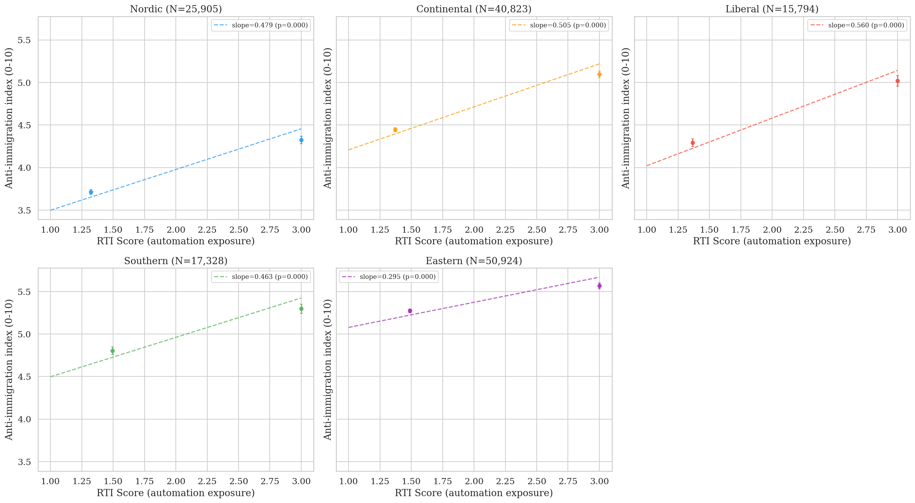
Figure 2. RTI vs. anti-immigration by welfare regime. Five-panel binned scatter.
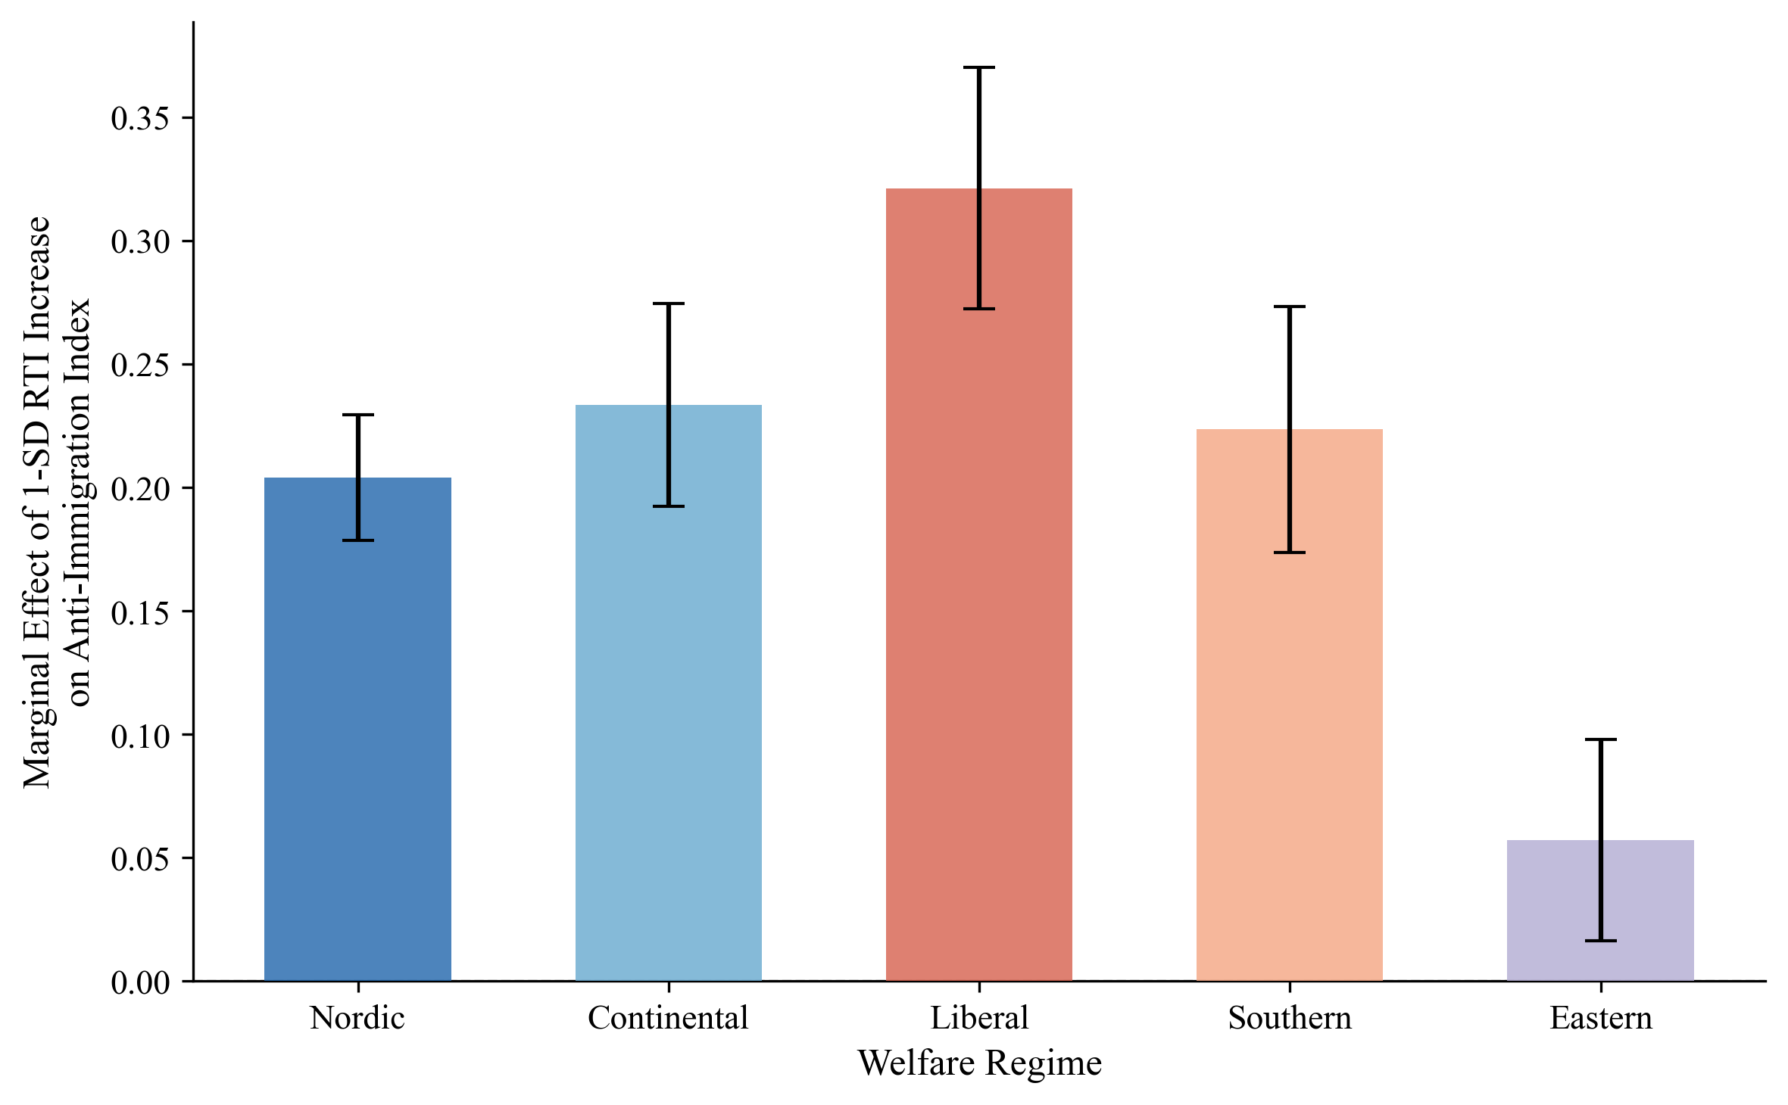
Figure 3. Marginal effect of 1-SD RTI increase by welfare regime.
D. The CWED Finding: Decommodification as the Operative Variable
Comparing two welfare measures produces the paper's most important finding. When individual countries' RTI→anti-immigration slopes are plotted against their ALMP spending levels (restricting to the same 15 Western European countries used in the CWED analysis), the correlation is near-zero (r=0.01, p=0.97, N=15). Countries spending more on active labour market policies show no systematically flatter or steeper vulnerability-to-exclusion slopes. Spending effort, holding sample constant, is unrelated to the exclusion pattern.
The picture changes dramatically when welfare is measured by its decommodifying quality. Figure 6 plots the same country-level slopes against CWED total generosity, the composite score capturing how effectively welfare systems enable workers to sustain living standards without employment. The correlation is strongly negative: r=−0.848, p<0.001, N=15 countries. Welfare generosity measured as decommodification is associated with 72 per cent of the cross-country variation in how strongly automation exposure co-varies with exclusionary attitudes. The United Kingdom, lowest in CWED generosity, shows the steepest slope. Norway, highest in generosity, shows the flattest.
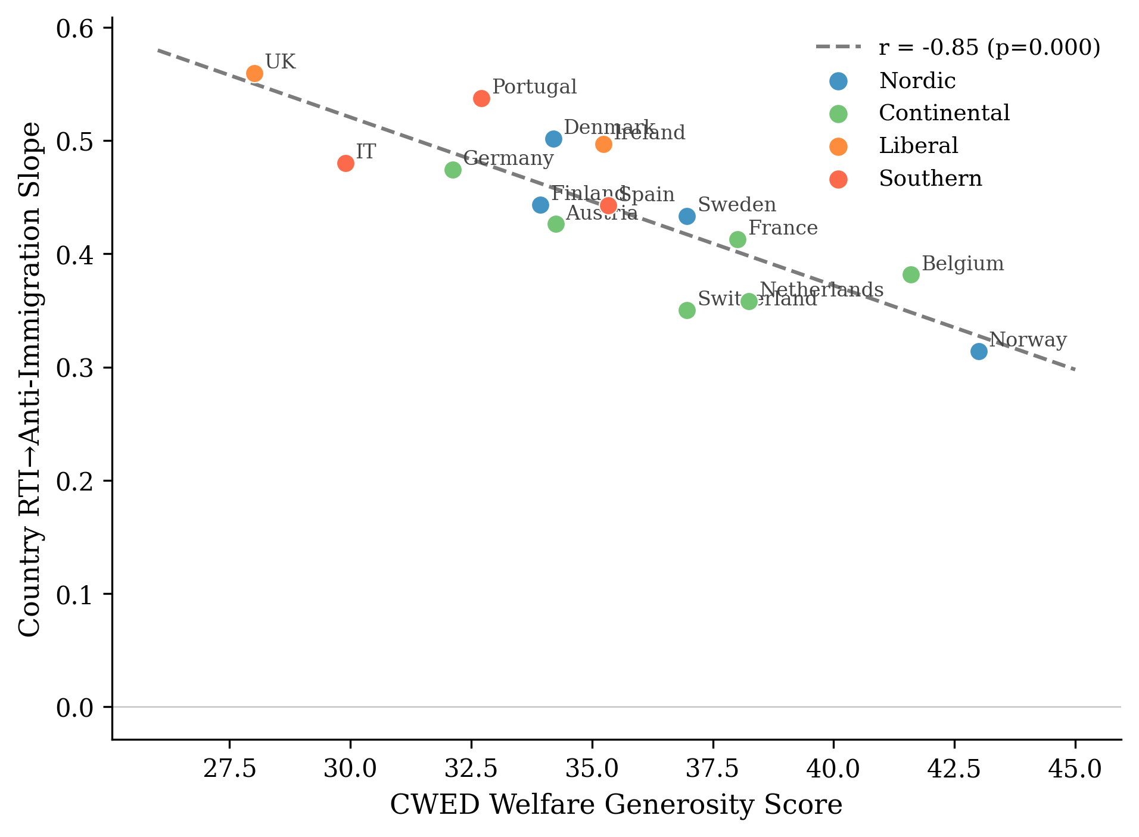
Figure 6. CWED generosity vs. country-level RTI→anti-immigration slopes.
At the individual level, Model 3 confirms this with the cross-level interaction:
Variable | β | SE | p
RTI | 0.215 | 0.025 | <0.001
CWED generosity | -0.069 | 0.064 | 0.281
RTI × CWED generosity | -0.059 | 0.024 | 0.015
The interaction is negative and significant (β=−0.059, p=0.015, N=81,885): a one-standard-deviation increase in welfare generosity reduces the marginal effect of RTI on anti-immigration attitudes by 0.059 scale points. The larger standard error relative to earlier specifications reflects the conservative random-slopes estimator, which absorbs cross-national slope heterogeneity. The finding strengthens with country-level GDP growth and Gini controls (β=−0.066, p<0.001), arguing against the concern that decommodification proxies for broader economic conditions.
The contrast between the ALMP and CWED results is the paper's central empirical argument, and it maps directly onto the theoretical distinction in §III. ALMP spending captures effort; governments can spend heavily on punitive workfare that communicates suspicion. Following Bonoli's (2013) typology and the more recent treatment in Van Hootegem (2025), ALMP aggregates across enabling programmes (upskilling, employment counselling) and punitive ones (benefit sanctions, behavioural conditionality), and the political signature of the punitive subset runs opposite to the enabling. CWED generosity captures decommodification; the degree to which the welfare state enables citizens to sustain themselves without dependence on market employment. CWED measures what the welfare state provides rather than what it demands. The asymmetric mechanism developed in §III predicts exactly the pattern observed: spending levels are unrelated to the exclusion slope; decommodification is.
Denmark presents an instructive complication. Despite high CWED generosity, Denmark shows a relatively steep RTI→exclusion slope (β=0.50), higher than Finland, Sweden, or Norway. Danish "flexicurity" combines generous benefits with high labour market flexibility and active job search requirements, creating a system generous in transfers but demanding in activation. Read through the asymmetric mechanism, this is not an anomaly but an additional piece of evidence; what damages the self-concept is conditionality and surveillance, even when transfer levels are high, because conditionality and surveillance are what communicate suspicion. The Denmark observation previews the within-country test the thesis design will perform. The activation-introducing reforms of 2003, 2006, and 2013 are exactly the kind of within-country shock the asymmetric theory predicts should produce damage signatures even with decommodification levels held relatively constant. The country-level finding is robust to all single-country exclusions: excluding the United Kingdom (lowest CWED) gives r=−0.802; excluding Norway (highest CWED) gives r=−0.794; excluding both simultaneously gives r=−0.717 (p=0.006). The result does not depend on any single case.
E. Main Models
Table 2 presents the multilevel results. Model 1 confirms that RTI predicts anti-immigration attitudes after controls (β=0.168, p<0.001, N=133,016). Model 2 introduces regime interactions with Nordic as reference:
Interaction | β | SE | p
RTI (Nordic baseline) | 0.194 | 0.025 | <0.001
RTI × Continental | 0.034 | 0.032 | 0.288
RTI × Liberal | 0.127 | 0.043 | 0.003
RTI × Southern | 0.029 | 0.039 | 0.454
RTI × Eastern | -0.132 | 0.031 | <0.001
Automation exposure is associated with anti-immigration sentiment significantly more strongly in Liberal welfare regimes than in Nordic ones (β=0.127, p=0.003). A one-standard-deviation increase in RTI is associated with 0.127 additional scale points of anti-immigration sentiment in Liberal compared to Nordic contexts, after controlling for individual characteristics. The larger standard errors compared to fixed-effects specifications reflect the random-slopes estimator; the substantive pattern is unchanged.
F. The Asymmetric Confirmation
The redistribution models confirm the asymmetric prediction set out in §III, and they do so in the place where the symmetric account most needed them to fail. RTI predicts slightly more redistribution support across all regimes (β=0.044, p<0.001). The cross-regime variation that drives the exclusion finding does not appear on the solidarity side: the RTI × Liberal coefficient is small, non-significant, and in the wrong direction (β=0.011, p=0.285). Welfare institutional context cleanly attenuates the conversion of vulnerability into exclusion. It does not detectably moderate the conversion of the same vulnerability into redistributive solidarity. That is the asymmetry, and it is more than the absence of a finding; it is what the theory predicted in §III.D and what the symmetric buffering account would have to deny.
The ISSP 2006 Role of Government module (N=10,216, 12 countries) provides a second test on a different sample, a different outcome variable, and a different time period. The result: no interaction between automation exposure and welfare generosity on unemployment spending support (β=+0.010, SE=0.016, p=0.55). A second null. The 2006 data predate the automation discourse of Frey and Osborne (2013) by several years. The protective pathway, on my reading of the asymmetric theory, requires automation exposure to register as a salient class-level threat in public discourse before solidarity can be politically organised around it. The damage pathway carries no such contextual requirement; a stigmatising welfare encounter does its work whether or not the underlying vulnerability has been culturally framed. Two nulls on solidarity, one in 2012–2018 ESS data and one in 2006 ISSP data, and a clear positive on exclusion in the same 2012–2018 ESS data. The asymmetry is detectable across temporal contexts in which the underlying material vulnerabilities are themselves shifting.
A measurement-problem reading of the redistribution null is available, and I am not in a position to rule it out conclusively. The substantive reading, which the asymmetric theory predicts, is that the null is the paper's strongest confirmation. Welfare design's political effects are real, are mediated by decommodification rather than spending, and run more reliably toward damage than toward repair. The within-country test the thesis design will perform is what would, in principle, distinguish the substantive reading from the measurement one. The cross-sectional test the present paper performs cannot.
A separate point requires honest treatment. The radical right voting models (Model 6) show RTI predicting radical right voting in Nordic countries (β=0.220, p<0.001) but the RTI × Liberal interaction is negative and significant (β=−0.123, p=0.032), opposite in direction to the attitudinal finding. This is not a substantive contradiction of the mechanism. It is what happens when supply-side institutions intervene between attitudes and votes. Ireland has no electorally significant radical right party. The UK's first-past-the-post system suppresses radical right seat conversion despite substantial UKIP vote shares (15–27% in the ESS waves 7–8 period). High-RTI voters in Liberal regimes channelled exclusionary preferences into Brexit support rather than into conventional party votes. The behavioural models are descriptive of electoral systems' translation of attitudes into votes; they are not tests of the asymmetric mechanism, which is a mechanism about attitudes. The supply-side question of how sorted attitudes become exclusionary politics is the question of a different paper.
G. Limitations
Several limits matter for how to read these findings. The cross-sectional design cannot establish temporal ordering. Country-level welfare indicators are confounded with other institutional differences; Nordic countries with high CWED generosity also tend to have higher social trust, stronger unions, proportional electoral systems, and lower ethnic heterogeneity, and the macro-controls robustness check (GDP growth, Gini) addresses macroeconomic confounders but not these deeper institutional correlates. The CWED finding, while striking (r=−0.848), rests on 15 country-level observations. The individual-level Model 3 interaction provides a more defensible test, but full identification requires within-country variation in welfare generosity over time, exploiting CWED changes following benefit reforms; a design I intend to pursue with Danish registry data in subsequent work. The asymmetric theory of §III is identified by the clear cross-national signal in the exclusion data and the corresponding null on the solidarity side. What the present design cannot do is rule out that the protective pathway is operating below the resolution of cross-sectional measurement, and a registry-based test of the within-individual recognition mechanism is the natural next step.
VI. Discussion and Conclusion
The evidence supports the asymmetric account theorised in §III. Welfare design shapes how economic disruption turns into exclusion. It does not equivalently shape how the same disruption turns into solidarity. Disruption processed through welfare institutions that preserve the self-concept does not, in this data, produce detectably stronger redistributive demand than disruption processed through institutions that damage it. Disruption processed through institutions that damage the self-concept does produce detectably stronger exclusionary attitudes. The damage mechanism is empirically legible across every specification this paper presents. The mirror-image protective mechanism is not.
The ALMP/CWED contrast bears directly on the theoretical argument. The buffering model asks how much the welfare state spends. The asymmetric mechanism asks something different: what the welfare state communicates, and to whom it matters. A country can spend heavily on active labour market policies that are punitive, conditional, and dignity-stripping, and that spending will register as "generous" in conventional measures while communicating suspicion to the people on the receiving end of it. Decommodification captures what spending alone cannot; the degree to which the welfare state enables citizens to maintain their living standards and, crucially, their sense of themselves without dependence on market employment. This is the institutional quality Banerjee and Duflo (2019) identify as the goal of social policy: absorbing shocks without allowing them to affect the self-concept. It is what Kurer and Palier (2019) mean when they argue that routine workers demand "economic and cultural protection" rather than material compensation alone. And it is what Gidron and Hall (2017) document when they find that right-populist voters "care as much, or even more, about recognition as about redistribution." Three literatures, three vocabularies, all pointing at the same underlying institutional dimension. The asymmetric mechanism is what makes them legible as observations of the same thing.
These findings change the long-running debate about whether radical right support has "economic" or "cultural" roots. Ciccolini (2025) argues the distinction is flawed because voters give a cultural reading to economic phenomena, and the present paper pushes that argument in an institutional direction. Welfare design is part of what shapes whether economic disruption receives a cultural reading in the first place. Cultural backlash is not a rival explanation to the economic one. It is what economic disruption looks like, cross-nationally, where welfare institutions are less decommodifying. Norris and Inglehart (2019) document a pattern consistent with what is reported here. What the asymmetric mechanism adds is the institutional conditions under which the backlash is more or less likely to fire, and the corresponding observation, which the cultural backlash literature has not had a clean way to make: the cultural reading of economic disruption has no symmetric counterpart on the protective side. There is no "structural-redistributive reading" of economic disruption that dignity-preserving welfare reliably produces in its absence. The asymmetry runs all the way down.
A note on what this paper does not claim. The argument is about attitudinal sorting, not vote translation. The behavioural results in §V.F (RTI predicts radical right voting in Nordic countries; the RTI × Liberal interaction is negative) are better read as confirmation of that distinction than as a puzzle. Attitudes sort. Supply-side institutions then determine whether attitudes become votes; party systems, electoral rules, and the available radical right options vary substantially across the welfare regimes compared here. The UK and Ireland in the ESS sample lack a conventional radical right channel for exclusionary preferences in the waves studied, and the Brexit referendum provided an unusual offramp for Liberal-regime exclusionary sentiment that conventional party-choice models cannot register. A full account of how sorted attitudes become exclusionary politics requires bringing supply-side variables into the analysis, and ideally extending the dependent variable beyond conventional radical right vote share. That is a separate paper.
The "dignity dividend," meaning the political returns to welfare design that preserves recipients' sense of themselves, is not captured by standard measures of generosity. It is a property of how welfare is experienced; of whether the encounter leaves a person feeling like a citizen navigating a shared challenge, or like a supplicant demonstrating worthiness. Developing measures of that experiential dimension, and testing whether the asymmetric mechanism survives the within-country variation that cross-sectional designs cannot identify, is the work the Danish registry follow-up is designed to do. The 2003, 2006, and 2013 activation reforms introduced conditionality of exactly the kind the asymmetric theory predicts should produce damage signatures, with underlying decommodification levels held relatively constant. That is as close to a quasi-experimental setting on the dignity margin as the available data permits.
The welfare state is, finally, more than a response to the politics of economic disruption. The cross-national patterns documented here are consistent with welfare design shaping the political direction of that disruption, a claim the present evidence supports associatively and that designs exploiting policy changes over time will need to establish causally. What the evidence does establish is narrower and firmer. Decommodification, not spending, is the dimension of welfare design along which the political consequences of economic disruption are visible. The consequences themselves are asymmetric; clearly toward damage, much less reliably toward repair. The buffering model's instinct, that welfare design matters politically, is correct. Its specific account of how welfare design matters (symmetric, quantity-based, intensity-modulating) is wrong in a way the data and the theory now make legible together. Dignity is a baseline good. The buffering model has been treating it as a quantity.

References
Alesina, A. and Angeletos, G.-M. (2005). 'Fairness and Redistribution.' American Economic Review, 95(4), pp. 960–980.
Albanese, G., Ferretti, G., and Ferroni, G. (2021). 'EU Structural Funds and Populism.' Working Paper.
Autor, D. H., Dorn, D., Hanson, G. and Majlesi, K. (2020). 'Importing Political Polarization?' American Economic Review, 110(10), pp. 3139–3183.
Autor, D. H., Levy, F. and Murnane, R. J. (2003). 'The Skill Content of Recent Technological Change.' Quarterly Journal of Economics, 118(4), pp. 1279–1333.
Ballard-Rosa, C., Jensen, A. and Scheve, K. (2022). 'Economic Decline, Social Identity, and Authoritarian Values.' International Studies Quarterly, 66(1), sqab027.
Banerjee, A. and Duflo, E. (2019). Good Economics for Hard Times. PublicAffairs.
Bergman, T. (2023). 'Industrial Decline and the Populist Radical Right.' European Journal of Political Research, 62(2), pp. 521–545.
Bonoli, G. (2013). The Origins of Active Social Policy. Oxford University Press.
Bonomi, G., Gennaioli, N. and Tabellini, G. (2021). 'Identity, Beliefs, and Political Conflict.' Quarterly Journal of Economics, 136(4), pp. 2371–2411.
Bornschier, S., Haffert, L. and Häusermann, S. (2024). 'Cleavage Formation: Universalism–Particularism and Electoral Realignment.' Comparative Political Studies, forthcoming.
Burgoon, B. and Schakel, W. (2022). 'Embedded Liberalism in Reverse? Welfare Generosity and Anti-Globalization Nationalism in Party Platforms.' Working Paper.
Busemeyer, M. R., Rathgeb, P. and Sahm, A. H. J. (2023). 'Authoritarian Values and the Welfare State.' Journal of European Public Policy, 30(1), pp. 77–99.
Caselli, M., Fracasso, A. and Traverso, S. (2021). 'Globalization, Robotization and Electoral Outcomes: Evidence from Spatial Regressions in Italy.' Journal of Regional Science, 61(1), pp. 86–111.
Ciccolini, G. (2025). 'Who Is Left Behind? Economic Status Loss and Populist Radical Right Voting.' Perspectives on Politics.
Colantone, I. and Stanig, P. (2018). 'The Trade Origins of Economic Nationalism.' American Journal of Political Science, 62(4), pp. 936–953.
De Blok, L. and Kumlin, S. (2022). 'Procedural Fairness and the Welfare State.' European Journal of Political Research, 61(4), pp. 863–885.
Ennser-Jedenastik, L., Köppl-Turyna, M. and others (2019). 'Cushion or Catalyst? Welfare State Generosity and Radical Right Voting.' European Political Science Review, 11(4).
Esping-Andersen, G. (1990). The Three Worlds of Welfare Capitalism. Princeton University Press.
Ferrera, M. (1996). 'The "Southern Model" of Welfare.' Journal of European Social Policy, 6(1), pp. 17–37.
Fetzer, T. (2019). 'Did Austerity Cause Brexit?' American Economic Review, 109(11), pp. 3849–3886.
Frey, C. B. and Osborne, M. A. (2017). 'The Future of Employment: How Susceptible Are Jobs to Computerisation?' Technological Forecasting and Social Change, 114, pp. 254–280.
Gallego, A. and Kurer, T. (2022). 'Automation, Digitalization, and Artificial Intelligence in the Workplace.' Annual Review of Political Science, 25, pp. 463–484.
Gidron, N. and Hall, P. A. (2017). 'The Politics of Social Status.' British Journal of Sociology, 68(S1), pp. S57–S84.
Gidron, N. and Hall, P. A. (2018). 'Populism as a Problem of Social Integration.' Comparative Political Studies, 53(7), pp. 1027–1059.
Gingrich, J. (2019). 'Did State Responses to Automation Matter for Voters?' Research and Politics, 6(1).
Goos, M., Manning, A. and Salomons, A. (2014). 'Explaining Job Polarization: Routine-Biased Technological Change and Offshoring.' American Economic Review, 104(8), pp. 2509–2526.
Guriev, S. (2024). 'Political Economy of Populism.' Journal of Economic Perspectives, 38(1), pp. 3–28.
Halikiopoulou, D. and Vlandas, T. (2016). 'Risks, Costs and Labour Markets: Explaining Cross-National Patterns of Far Right Party Success in European Parliament Elections.' Journal of Common Market Studies, 54(3), pp. 636–655.
Häusermann, S. (2024). 'Politics and Social Policy in the New Inequality.' Annual Review of Political Science, 27.
Häusermann, S., Kurer, T. and Zollinger, D. (2023). 'Universalism vs. Particularism.' Political Science Research and Methods, 11(4).
Haugsgjerd, A. and Kumlin, S. (2020). 'Downbound Spiral?' West European Politics, 43(4), pp. 969–990.
Im, Z. J. (2023). 'With Status Decline in Sight: Voters Turn to the Radical Right.' European Political Science Review, 15(4).
Im, Z. J. and Komp-Leukkunen, K. (2021). 'Automation and Workfare Support.' Journal of European Social Policy, 31(4), pp. 456–472.
Im, Z. J., Mayer, N., Palier, B. and Rovny, J. (2019). 'The "Losers of Automation".' Research and Politics, 6(1).
Iversen, T. and Soskice, D. (2001). 'An Asset Theory of Social Policy Preferences.' American Political Science Review, 95(4), pp. 875–893.
Jeffrey, K. (2020). 'Automation and the Future of Work: How Rhetoric Shapes the Response.' Working Paper.
Kahneman, D. and Tversky, A. (1979). 'Prospect Theory: An Analysis of Decision under Risk.' Econometrica, 47(2), pp. 263–291.
Kurer, T. (2020). 'The Declining Middle.' Comparative Political Studies, 53(10–11), pp. 1798–1835.
Kurer, T. and Palier, B. (2019). 'Shrinking and Shouting: The Political Revolt of the Declining Middle in Times of Employment Polarization.' Research and Politics, 6(1).
Kurer, T. and van Staalduinen, B. (2022). 'Disappointed Expectations: Downward Mobility and Electoral Change.' American Political Science Review, 116(4), pp. 1340–1356.
Kuziemko, I. (2023). 'Compensate the Losers? Economic Policy and Partisan Realignment in the US.' Working Paper.
Larsen, C. A. (2008). 'The Institutional Logic of Welfare Attitudes.' Comparative Political Studies, 41(2), pp. 145–168.
Mettler, S. (2011). The Submerged State. University of Chicago Press.
Milner, H. V. (2021). 'Voting for Populism in Europe.' Comparative Political Studies, 54(13).
Norris, P. and Inglehart, R. (2019). Cultural Backlash. Cambridge University Press.
Patrick, R. (2016). 'Living with and Responding to the "Scrounger" Narrative.' Journal of Poverty and Social Justice, 24(3), pp. 245–259.
Pelc, K. (2025). 'Wage Buyouts and Attitudes to Non-Work.' Working Paper.
Pierson, P. (1994). Dismantling the Welfare State? Cambridge University Press.
Rothstein, B. (2001). 'The Universal Welfare State as a Social Dilemma.' Rationality and Society, 13(2), pp. 213–233.
Ruggie, J. G. (1982). 'International Regimes, Transactions, and Change.' International Organization, 36(2), pp. 379–415.
Soss, J. (1999). 'Lessons of Welfare.' American Political Science Review, 93(2), pp. 363–380.
Stutzmann, M. (2025). 'The Political Consequences of Coal Phase-Outs.' Working Paper.
Van Hootegem, A. (2025). 'The Two Faces of Activation: Enabling vs Demanding ALMP and Public Support.' Journal of European Social Policy, forthcoming.
Van Hootegem, A., Abts, K. and Meuleman, B. (2021). 'The Duality of Welfare Criticism.' Social Indicators Research, 156, pp. 123–140.
Vlandas, T. and Halikiopoulou, D. (2022). 'Welfare State, Economic Insecurity, and the Radical Right.' Journal of European Public Policy, 29(1), pp. 24–46.
Wagner, P. (2022). 'Kicking Down on the Ladder of Deservingness: Attitudinal Reactions to Experiences with Welfare Conditionality.' Working Paper. doi:10.31235/osf.io/arvh5
Wu, N. (2022). 'Misattributed Blame?' Political Science Research and Methods, 10(3), pp. 470–487.
Appendix A: Robustness Checks
Figure A1 presents a coefficient stability plot for the RTI × Liberal interaction across specifications. The coefficient ranges from 0.073 (jackknife excluding GB) to 0.161 (jackknife excluding IE), with a jackknife mean of 0.117 and standard deviation of 0.013. The result survives exclusion of Eastern European countries (β=0.128), removal of the income control (β=0.132), and inclusion of left-right self-placement (β=0.116). The 95% confidence interval never includes zero in any specification.
The CWED×RTI interaction is similarly robust. Adding country-level GDP growth and post-fiscal Gini as macro controls — sourced from the Comparative Political Data Set over 2012–2018 — leaves the buffering coefficient essentially unchanged (β=−0.066, p<0.001), arguing against the concern that decommodification proxies for broader economic conditions rather than welfare quality per se.
Figure A1 here: Coefficient stability across robustness specifications.
Appendix B: Education Moderation
The descriptive analysis reveals that the RTI→anti-immigration relationship is steeper for non-college workers in all regimes. In Liberal regimes, the bivariate slope drops from 0.280 (non-college) to 0.128 (college) — a 54 per cent reduction. This pattern is consistent with the theoretical prediction that education provides alternative identity resources buffering the switch from class to cultural identity.
Figure B1 here: RTI→anti-immigration slopes by education and welfare regime.
The formal three-way interaction (Model 4: RTI × regime × non-college) shows a positive but non-significant coefficient for the RTI × Liberal × non-college term (β=0.084, p=0.179). The formal test does not reach conventional significance thresholds. The descriptive pattern is consistent with the theoretical prediction — and parallels the finding of Ballard-Rosa, Jensen, and Scheve (2022) that education buffers the economic decline → authoritarian values pathway — but should be treated as exploratory pending a design with adequate statistical power for three-way interactions.
Appendix C: The Solidarity Pathway — Supplementary ISSP Test
Model 5 (redistribution support, gincdif reverse-coded 1–5) shows RTI predicting slightly more redistribution support everywhere (β=0.044, p<0.001), but the cross-regime interaction does not match symmetric predictions: the RTI × Liberal coefficient is small, non-significant, and in the wrong direction (β=0.011, p=0.285). The institutional moderation of the vulnerability→solidarity pathway is not detectable in the ESS data — a result the asymmetric theory of §III predicts and the empirical analysis of §V.F treats as confirmation rather than limitation.
The supplementary test using the ISSP 2006 Role of Government module (N=10,216, 12 countries) reported in §V.F provides further detail. Model: solidarity ~ task_z * cwed_z + controls + (1 + task_z | country). RTI × CWED interaction: β=+0.010, SE=0.016, p=0.55. OLS cross-check: β=−0.012, p=0.77 (opposite sign). Main RTI effect: β=−0.109 — routine workers in 2006 wanted less spending, before the automation discourse of Frey and Osborne (2013) reshaped how these workers' material position was being culturally framed. The temporal scope condition matters for the asymmetric theory: it suggests the protective pathway requires automation exposure to register as a salient class threat, not merely as individual occupational risk, while the damage pathway is detectable without similar contextual scaffolding because conditional welfare encounters carry their own salience.
The redistribution asymmetry — clear exclusion effects, no detectable solidarity effects — is consistent across the ESS Model 5 null and the ISSP Model 5 null. Distinguishing residual measurement limitations from the substantive theoretical asymmetry developed in §III requires panel data tracking individuals across periods of welfare reform — a design I intend to pursue in subsequent work.

